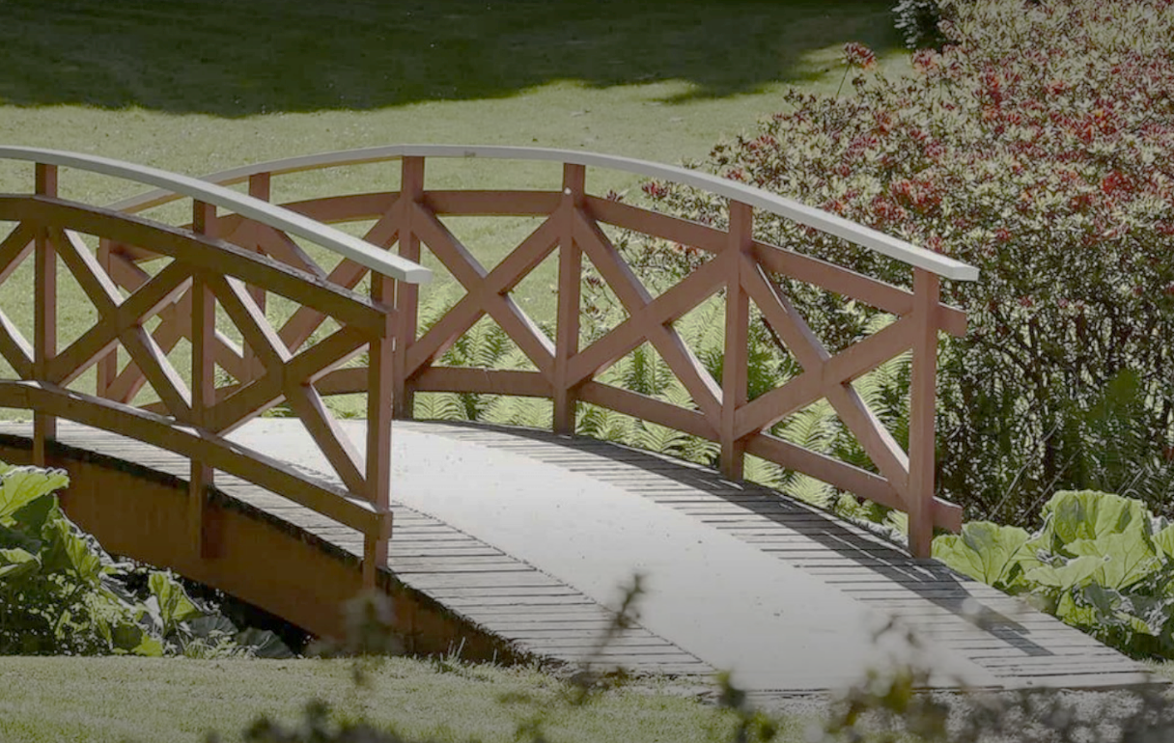

Retail Circle - Offsite

Author:
Dann Bleeker Pedersen

ABSTRAKT

Event name
Objective
Participants
Location
Data & time
Facilitator | Dann Bleeker Pedersen
Venue settings

Table of contents
1. Setting up the venue 1
2. Process 2
3. Follow-up activities 5
FLIPCHARTS NEEDED 6
Appendixes 10

Setting up the venue
- Interact with venue owner about rules, regulations, support, etc.
- Chairs and tables are setup as requested
- Flipcharts are available
- Markers for flipcharts are available and work
- Crayons to flipcharts
- Projector/screen works and is tested
- Power for electronic devices is setup
  - Computer
  - Camera
  - Phone
  - Music
- Setup musical setup
- Prepare and start timelapse pictures
- Prepare needed workshop kit
  - Post-its
  - Markers

- Notepaper and pens for participants
- Decide where to hang flipcharts
- Share Wifi code with participants
- Ensure that all needed handouts are ready

- Way-before: Send out agenda and set expectations.. .prep package if needed

Process
Headline | Minutes | Process | Output / Results | Material needed
SESSION OPENING
Before start | - | - Music plays to give a bit of energy | Team is ready to start | - Standard music package  - Speakers  - Charging cables and chargers  - Extension cords for power  - Music available offline  - Dedicated phone for playing music
Welcome | 5 | - Welcome participants  - Say you looked forward to the day  - Explain purpose of the session  - Remember: today is the beginning of a journey. Expect follow-up actions  - Inform about practical stuff: breaks, toilets, Wi-Fi, etc. | - | - Flipchart: purpose statement for the meeting
Venue introduction | 10 | - Venue and its history is presented, if venue is different from the standard venue | A bit of a special feel, due to the understanding and respect from the venue | - Presenter from the venue
Expectations | 10 | - Ask participants for their expectations for the session  - Use: Think-pair-share or think-share  - Ask for input on post-its  - Facilitator to sum-up expectations and get agreement of follow-up  - Facilitator to discuss with team if expectations can be reached with planned session. Possible be willing to rearrange or redo the session on the fly, if needed. | Insights into participants expectations and ability to set their expectations straight for the purpose of the session | - Flipchart: Expectations
Agenda walkthrough | 5 | - Post each agenda item in the “agenda backlog” part of the flipchart  - When each is posted, state the purpose of that agenda item and who will run it  - State that it is a prioritized backlog. We will focus on completion of the selected topics, not in emptying the backlog  - Ask for feedback of missing items on the agenda | Agreement and alignment on agenda | - Flipchart: Agenda backlog  - Post-its with agenda items and responsible. Different colors (with meaning) should be used if possible  - Blank post-its  - Markers
Process for session | 3 | - We will use a parking lot during the meeting. Post-its will be posted if we need to postpone a topic that pops up  - Actions will be noted on flipcharts for everyone to see  - Review any earlier agreed ground rules with team  - I will be mining for conflict | Accept of process | - Flipchart: Actionlog  - Flipchart: parking lot
Ground rules | 7 | - Let’s agree on the behavior we should have for this and future sessions  - Questions to ask: Think about great meetings, what made them great? How should we act in these meetings to make them efficient?  - A different approach is to ask each individual to come up with personal commitments that they will contribute to making the meeting great, and then ask to share. If this is done, then review at the end of the session.  - Capture what is said, and if needed get everyone to sign the flipchart for extra buy-in.  - Examples of rules can be electronics on stun, let everyone speak, include breaks for every hour, must end on time, etc..  - Facilitator: Note the flipchart should and must be posted visible during the meeting  - Facilitator: Remember to point to the flipcharts and give feedback (good and bad) during the meeting to set the tone | Ground rules to be used for the meeting | - Flipchart: Ground rules
AGENDA ITEMS
ActionLog follow-up | X | - Review action log and ask for (short) status updates from task owners.  - Use the parking lot if something needs a lot of elaboration | Updated action log and agreement on current status of open tasks | - Electronic action-log  - Ability to display action-log
SESSION CLOSURE
Communication | 5 | - We need to speak with one voice after our discussions  - What will we communicate from here?  - Ask for feedback from the room. Write down feedback on the communications chart  - Ask: How should we communicate this? Written, oral, etc.? | Alignment on communication messages | - Flipchart: Communication  - Markers
Closure of session | 10 | - Thank you for your participation  - Refer to agenda and review results  - Review parking lot and decide what to do with the items  - Review actions and fill in any blanks  - Refer back to purpose flipchart. Q: Did we make it? | Mental closure and alignment on possible next step | - -
Evaluation | 5 | - Ask for feedback for the session  - Each to prepare full sentence post-its. A minimum of 2 “went well” and 1 “take a look at”  - Go around the room to present  - If pressed for time, ask for the group to post the feedback on the flipchart on their way out | Learning for next sessions | - Flipchart for evaluation (what went well, take a look at)  - Post-its and markers for all participants
After meeting |  | - Music plays  - Take pictures of all material to include in after action report | - | - Standard music package  - Speakers  - Charging cables and chargers  - Extension cords for power  - Music available offline  - Dedicated phone for playing music

Follow-up activities

- Write summary from session
  - Thank you for active participation
  - Include agenda, minutes, action-log, evaluation, etc.
  - If a next session is scheduled, inform about it
  - Thank for participation
- Update electronic action-log
- Give feedback to any participants based on their behavior
- Share all pictures and other material with participants
- Write after-action notes to any needed stakeholders
- Conduct evaluation with session owner

FLIPCHARTS NEEDED
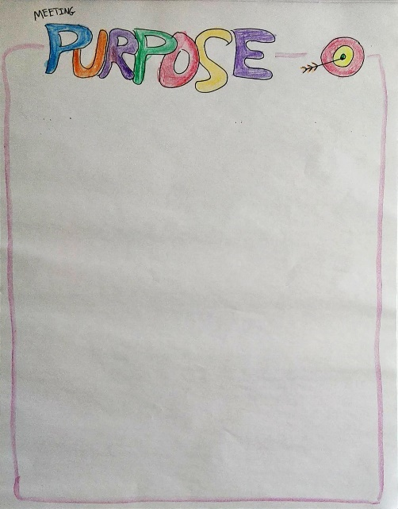 | Purpose  Any meeting should start with a short presentation of the purpose of the meeting. For shorter meetings, a visual representation is not needed. For longer meetings, it’s recommended to keep the purpose visible during the entire meeting to keep the participants on track.  If a meeting is a collection of smaller meetings bundled into one, then skip the purpose for the meeting but ask that each owner for an agenda item quickly starts by stating the purpose of the agenda item.  Start with getting agreement from the participant that the purpose is the right one.  It’s recommended to write directly on the flipchart. If that is not feasible, use post-its.
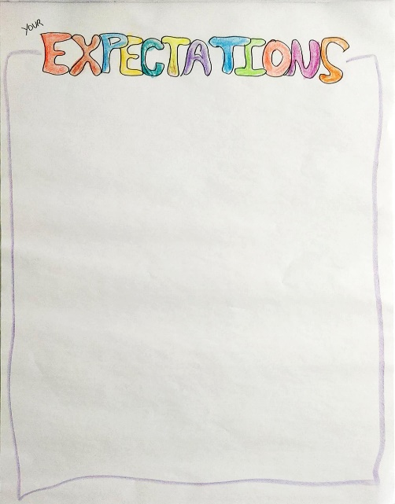 | Expectations (from participants)  In longer sessions with a diverse set of participants, it is recommended to ask the participants what they have of expectations to the meeting.  Depending on the group size, there could be some preparation work in smaller groups before a discussion with the entire room.  Gather all the input and write it as said by the participants. If something seems covered already, ask before you dismiss it.  In the end, comment on the expectations. What can be matched, and what cant. Discuss any changes to the agenda, if needed.
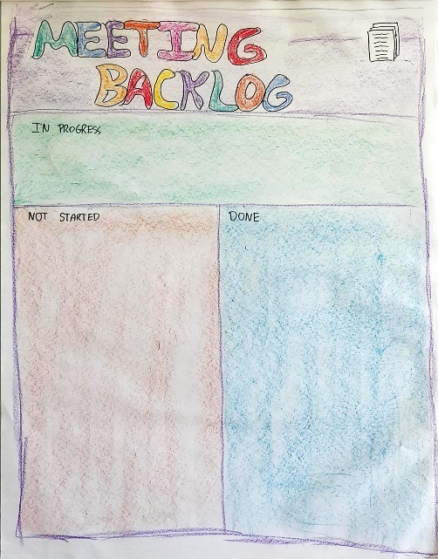 | Meeting backlog (agenda)  Based on both the purpose and the expectations of the participants, it is not time to set the agenda.  Use premade post-its for each agenda item. Put them in the not started column as you talk to each point. If there are several themes or types of agenda items, consider using different colors for the post-its to symbolize this.  Ask if anything is missing and add accordingly.  During the meeting, move the post-it for the current topic to “in progress” and afterward to DONE. This is a nice visual reminder of what we are focusing on now.  If pressed for time, be sure to prioritize the not started column and push any items not processed to another session or other ways of processing.
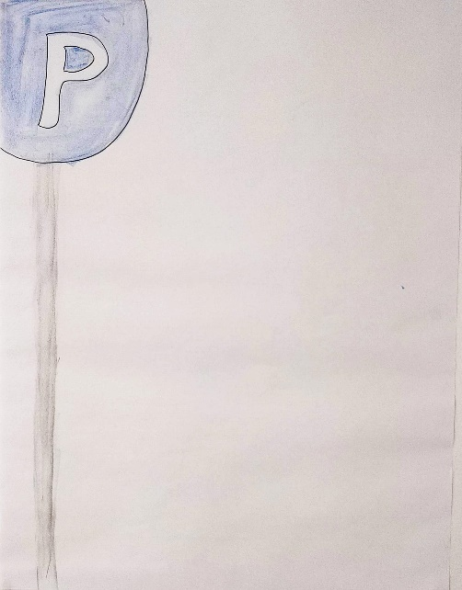 | Parking lot  Discussions often run off on a tangent to the topic at hand. Usually, there is not enough time to process all of these other ideas. Therefore, make a parking lot to help secure focus.  Introduce the parking lot after the agenda as the collective memory for us, to remember topics that surface, but are not part of the agenda. Having the visual reminder is excellent to make sure that the participants feel heard and that the focus of the group can be kept.  Every time a new topic surfaces in the discussions, and you need to close the debate, make a post-it on the point and put it on the parking lot flipchart.  Remember to end the meeting with emptying the parking lot. Emptying is done by processing the items, if there is time, delegating if possible or scheduling a follow-up.
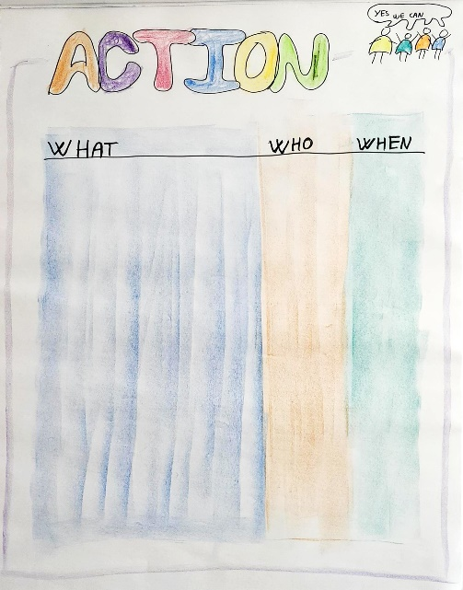 | Actions  During most discussions, someone will need to take action. Decisions should be implemented; something must be investigated, or any other action can pop up during a meeting.  To make sure actions are captured, write them in the simple format of what is done by who by when. Make it visible to all during the meeting.  At the end of the meeting, the action list is reviewed to make sure everyone agrees. Remember to distribute the action list to participants afterward. It could be as simple as taking a picture, or it can be put into a system, depending on the preference of the participants and their modus operandi. When closing the meeting, be sure to gauge their commitment level to implementing the actions. If the commitment is not there, then discuss if something needs to be changed.
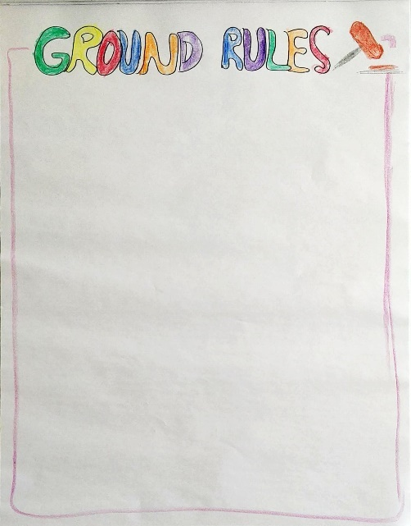 | Ground rules  Depending on the participants, it can be a good idea to define some ground rules for the meeting (or series of meetings). Ground rules describe how you participate and what you expect of each other and yourselves.  Good questions to ask: Think about great meetings, what made them great? How should we act in these meetings to make them efficient?  A different approach is to ask each individual to come up with personal commitments that they will contribute to making the meeting great, and then ask to share. If this is done, then review at the end of the session.  Capture what is said, and if needed get everyone to sign the flipchart for extra buy-in.  Examples of rules can be electronics on stun, let everyone speak, include breaks for every hour, must end on time, etc..
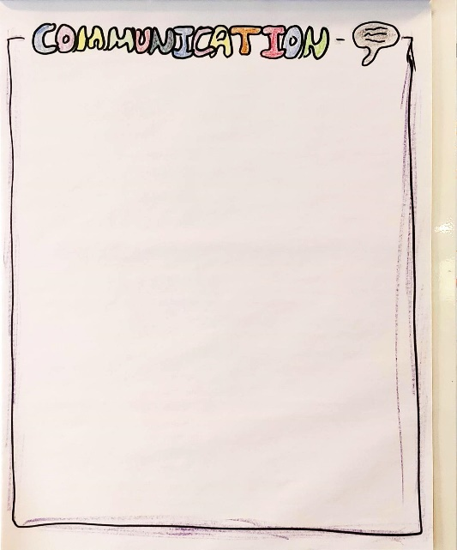 | Communication  Ending a meeting should include a summary of what was achieved. To ensure that each participant shares the same message when they leave the meeting, it is strongly recommended to end each meeting with a simple summary of what to communicate.  Ask the participants for what should be shared from the meeting. Write each point on the flipchart.  Remember to state the actions should also be communicated.
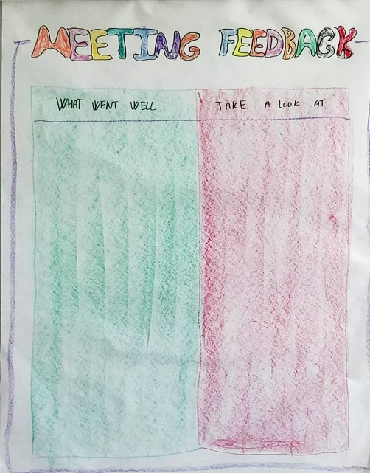 | Meeting feedback / Evaluation  It is good practice to end a meeting by asking what went well, and what should be improved. There are a lot of different methods for doing this.  This method is done by asking each participant to fill out post-its for “what went well” and “take a look at”. Each post-it should be written as a full sentence so that it can be understood later on.  Either share directly and talk about the input as each participant post it (in this case, pre-work in groups can be used) or simply ask everyone to place their post-its on the flipchart placed near the door as their “ticket” to leave the meeting.  No commitments are given based on the evaluation, that is for the facilitator to decide at a later date.

Appendixes
APPENDIX 1: Headline 1

- Headline

