Generic goals for an IT function

Author:
Dann Bleeker Pedersen

Date:
2020-09-27

PREFACE
During the last three years, I have been developing the model shown in this article. I needed to have a framework to help me thinking through different complex organizational design issues. The model have helped med do just that.

I do not pretend that the model shown is perfect, simply that it helped me in my thinking. I am sharing it in the hope that it might inspire others thinking as well.

The thinking is very generic and free from the actualities of the implementation of the model. While this is where the real value lies, I have chosen to keep this article to the more generic overall theoretical goal thinking for an IT function.

Special thanks to the many who have helped refine my thoughts throughout the last couple of years.

Indholdsfortegnelse
1. Generic goal for an IT function 1
1.1. Zooming into IT 1
1.2. Setting boundaries 2
1.3. Breaking down the generic goal for IT 3
1.4. Developing and implementing 3
1.5. Efficient operation 4
1.6. Summing up level two of the goal breakdown 5
1.7. Breaking down sub-goal A 5
1.8. Breaking down sub-goal B 7
1.9. Putting it all together 9
References 10

Generic goal for an IT function
Any organization have one (or more) goals. It is the duty of every member of an organization to work towards the overarching organizational goal. In larger organizations, the overall goal of a company is often broken down into sub-goals, so each division, department, team and individual can easily see how their work contributes to the overall goal of the company. This process of breaking down a goal into smaller parts is often called cascading. A process perhaps best known from the Balanced Scorecard approach to cascading.

In any system, it is important to ensure that everyone is focused on the overall goal. If not, inefficiencies can easily occur. Examples includes suboptimization, wrong allocation of capital and much more. While the overall goal remains the most important goal in the organization, there can be a very long (and sometimes indirect) causality chain from any individual in an organization and their impact on the overall goal. It is the role of management to ensure that the organizations overarching goals are broken down in such a way as to make it clear how each individual’s contribution is target at achieving the overall goal.

Breaking down goals in any cascading approach is done through a sufficiency logic, in such a way that each components of a goal must be just enough to ensure that the overall goal is reached. A goal can be anything from ending world hunger to increasing shareholder value or anything in between. What is important is that each goal is broken down in smaller chunks that, taken together, ensures that the overall goal is reached.

There are many methods of doing this goal breakdown. Examples include, Balanced Scorecard, Objectives & Key Results, OGSM (Objectives Goals Strategies and Measures), and Goal Tree. What is important is the logical breakdown and adaptability to changing circumstances that the method supports. And in the end, it is never the method used, but the way the method is employed that counts.

Zooming into IT
In an organization organized along functional lines, IT is often a separate department. The following is based on the assumption that this organizational principle is used. In such a setup, the role of the IT department is to contribute to the organizations overall goal achievement. Assuming that the organization is not in the IT industry, and the IT department is, therefore, not creating the entire product of the organization. In other words, IT is an support function in the organizations value chain.

Based on the stated assumptions, it is possible to ascertain that the IT function needs to support the organizations ability to reach their overall goals. Furthermore, the role of any organization is not only to reach the goals in any given time period, but also in the next. We can therefore, tentatively formulate the goal of an IT function as follows:
Support the entire organization in reaching the overall goals both now and in the future.
While correct, this definition is a bit too generic. It would be relevant for any support function in a company. The definition needs to be worded more specifically towards the IT departments abilities and reason to exists. Any IT functions primary goal is to deploy IT in a organization in such a way that it supports the achievement of the overall goal. With this insight, we can update the overall statement as follows:
Utilize technology to support the entire organization in reaching the overall goals both now and in the future.
Depending on temperament and ambition, the wording could be changed from support to ensure and many other fine tuning possibilities. The current statement is a bit free of responsibility, since the goal is only to support, which could be interpreted as do you best, no matter the results. To tighten this up a bit, we end up with the following generic goal statement for an IT function:
Ensure that technology is utilized to support the organization in reaching the overall goals both now and in the future.
Notice that the word entire have been removed from this statement. This have been done, since it otherwise could be interpreted as each and every part of an organization should be supported by technology. This might not be in the best interest of the company, and have therefore been removed.

This overall goal for an IT function needs to be broken more down into different sufficient sub-goals. Before we do that, however, please note that this goal is generic and should therefore never be used as the endpoint for setting any goal for any organization, but could be used as either inspiration or the starting point for defining the correct goal in the context of the specific organization. The generic goal is just a theoretical exercise, that needs to be supplemented with real world and context based insights.

Setting boundaries
While the stated generic goal for an IT organization seems true, it can’t stand on its own. In any organizations there are boundaries and rules that each function must adhere to. While most of these are specific to each individual organization, there are at least one generic boundary as well.

No organization have unlimited funding. And even if they did, there is, in any organization, a fiduciary responsibility to deploy the companies resources in a responsible way. In other words, even in a situation with unlimited funding, you must put in constraints to ensure that only ideas with a sufficient cost compared to the goal achievement is implemented. Therefore, it is safe to say, that in all practical cases, there will be a boundary set by one (or several) financial constraints by the overall organization. The assumption is therefore that each IT function has an boundary as stated below:
Financial restrictions must be adhered to
Financial restrictions comes in all shapes and sizes. Some are specific on individual cost categories and types. Others might just be a lump sum. That will depend on the specifics of the organizations chosen financial management setup. On a generic level, we therefore keep the statement as is.

Breaking down the generic goal for IT
Based on the analysis so far, the following illustration of the generic goal of an IT function can be made:
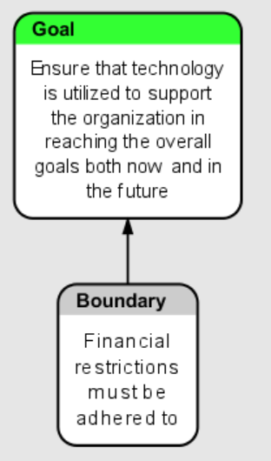
While interesting as an intellectual exercise, the staged generic goal is at a very high level. It does not really aide in the management of any IT function. Therefore, we need to break the goal down into the next level of sufficient sub-goals.

Any IT function have two very different areas of responsibility:
- developing and implementing new IT features/abilities
- ensuring an efficient operation of current features
While this seems technically correct, we need to think a bit deeper on both of these sub-goals.

Developing and implementing
Starting with the sub-goal for developing and implementing IT features/abilities, there are several things that needs to be refined. First of all, it is necessary to take the timelines into consideration. The current statement focuses on the here and now. While the present time is incredibly important, it is also important that any decisions made does not make the future ability to deliver upon the goal worse. In an ideal situation the ability to deliver upon this goal needs to improve over time, so the overall capacity to deliver new features increases. Based upon this, the statement is modified to include the addition “now and in the future” to signify the balance between both now and later.
- developing and implementing new IT features/abilities now and in the future
Second of all, the word IT features/abilities can be understood as a pretty narrow focus, since this does not necessarily include basic deliveries of an IT organization such as network and the like. Furthermore, features/abilities could also be read as not including new suite of applications and the like, therefore, a broader term is abilities. To make sure that the wording of the sub-goals includes all relevant deliveries of new IT features/abilities, the generic word assets will be used. The purpose is to encompass everything that is delivered form an IT organization. The new wording of the sub-goal is therefore:
- developing and implementing new IT assets now and in the future
Third of all, the word new can be construed as only meaning significant new things, when the word assets have been introduces. Since the goal is to develop and implement what is needed to support the organizations overall goal, both large and small deliveries needs to be included. The word new is therefore removed from the wording. This brings us to:
- developing and implementing IT assets now and in the future
Fourth, and last, the wording is focused on looking at the specific IT assets. In other words, if an IT organization delivered many new IT assets (in the broadest definition of the word), then the IT function would classified as an success, according to this. In some sense, this is correct. IT delivers IT, what the rest of the company uses it for is not really ITs problem, right? In our context, where we want to make sure that the different goals in our hierarchy is aligned with the overall goal of the organization, this needs to be rectified.

In a generic way, this is a simple fix. We simply need to add that IT should contribute to the goal fulfilment to achieve this goal. One way of wording this is below:
- developing and implementing IT assets, that moves the organization towards its goal, both now and in the future
While this is an easy fix on paper, it is incredibly hard in real life. Achieving this alignment of goals is one of the most difficult things to achieve in regards to financial management, portfolio management and governance. This is hard, since it is necessary both to do what is needed but also to not to do what do not bring us closer to the goal. An discussion non how to achieve this in the real world is outside the scope of this article, we will therefore close this subgoal here, with a slight change in the wording to align with the same grammatical tense as the overall goal:
- develop and implement IT assets, that brings the organization towards its goal, both now and in the future

Efficient operation
The other sub-goal is all about ensuring an efficient operation of the features already in production. Following the discussion above, regarding sub-goal a, the wording will be changed along similar lines. That brings us to the following goal formulation:
- ensure an efficient operation of IT assets, both now and in the future
The exact definition of efficient remains in this statement. What does it actually mean to have an efficient IT operation? Defining that will, however be a matter of breaking down the sub-goal one level more to define how to achieve it, and by doing that also defining more closely what it means in real life to have an efficient IT operation.

Behind the stated goal, there is the assumption that the IT assets are valuable to the company based on the continued development from goal a. Implicit herein also lies the assumption that goal a will ensure a decom based on missing value creation, while goal b ensures optimizations from a cost perspective, among others.

Summing up level two of the goal breakdown
Putting the work from above together in one illustration renders the following picture:
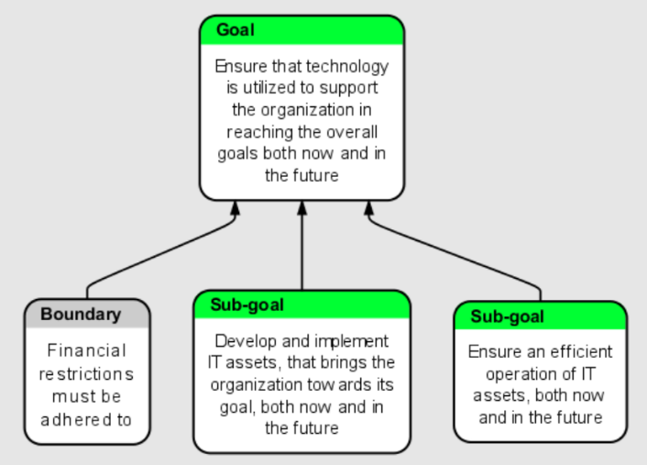
This sub-goal level adds some clarity to the overall goal for an IT function. Already now, see some of the foundation behind many traditional organizational structures with a development and an operations team. We also see the foundation towards the central conflict behind these two departments, and the core conflict that the DevOps movement tries to solve.

Looking at this, however, it seems possible to dive one level further down create even more clarity. This is the purpose of the following sections.

Breaking down sub-goal A
The stated sub-goal was finally worded as follows:
Develop and implement IT assets, that brings the company towards its goal, both now and in the future
This sub-goal is all about creating and implementing new assets, that brings the organization towards its goal. In other words, the most thing here seems to be the fact that we actually moves the organization towards its goal. If we define value for the organization, in this context, as a contribution to moving the organization towards its goal, then we can state the following first condition needed to achieve the goal:
- Creating as much value with IT assets as possible, both now and in the future
Please note that this statement is very broad, since it encompasses both the creation of the IT asset, but also the needed implementation work and change management to ensure that the IT assets generates value for the organization.

This initial condition cannot stand on its own. Without any constraints put on it, we would have a situation where we would produce more new assets than we can manage as a company. The development capacity is the main constraint here. It is, naturally, implied that the necessary work of management is to constantly increase capacity so the ability to deliver on the goal increase in the future. However, to avoid spiraling costs and the risk of breaking the boundary constraint put in place, we will add a second condition relating to the financial constraints:
- Minimize the cost (and time) of developing and implementing IT assets, both now and in the future
While important to minimize costs, the fundamental assumption is that the value created from new assets should and must be bigger than the cost of producing them. The condition to minimize costs is therefore, by its nature (in most normal situations) less important than creating value. This should be treated as a necessary but not at all sufficient condition.

Furthermore, the focus is not on the cost base as a totality, but on the cost of the specific creation of assets. This, therefore, implies that there is a need to pay down technical debt to ensure the achievement of this condition in the future. Any impact from the sins of the past cannot be mitigated in the present, but most constantly be improved to ensure the achievement of this condition.

In any production environment, there is the possibility to produce to inventory. IT is no different. New assets can be created, but never deployed. New assets can also be created in such a way that the lead time from initial idea to final implementation is very long. Not only does this create a long idea to goal achievement timeline, but it also introduces the question of why we would ever consider doing work that is not utilized as fast as possible. Even worse, if we produce to inventory, we could end up creating IT assets, that are never used to create value for the organization. While these examples might seem far-fetched from a theoretical perspective, they are frequent occurring in real life. We therefore introduce a third condition:
- Minimize the value of IT-inventory (assets not in production)
Examples of inventory can be licenses or applications that have been bought, but not implemented. It could be pre-analysis done, but the following work is pending. It can be lines of code created but not put in production yet. Minimizing the value of the IT-inventory seeks to avoid these situations as much as possible. Notice that there is now “now and later” in this statement. The reason is that the inventory should be as low as possible at all times, but the way to achieve that is to focus on keeping it low, not on planning to decrease it in the future.
Combining the statements above and changing to the present tense grammatically, where needed, gives the following breakdown of sub-goal a:
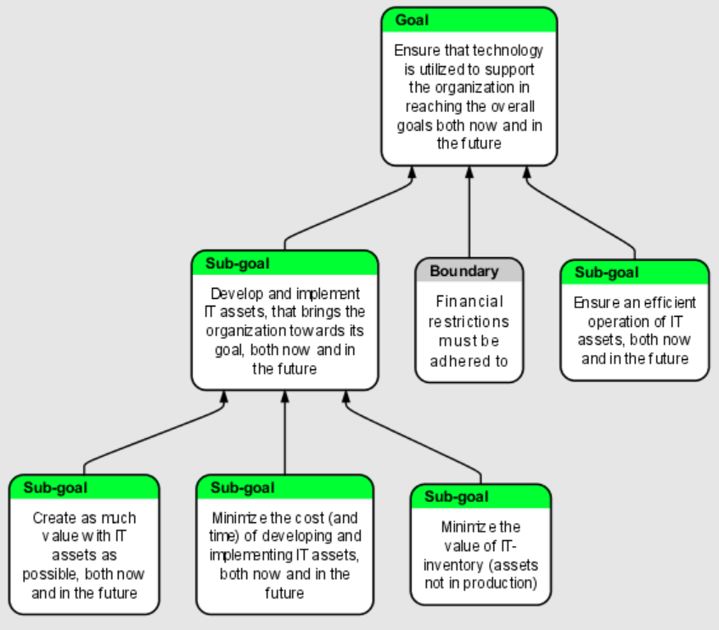

Breaking down sub-goal B
Following the breakdown of sub-goal A, it is time to do the same for sub-goal B. Sub-goal B was stated as the following:
Ensure an efficient operation of IT assets, both now and in the future
The main question naturally becomes, what does efficient means for an IT organization. When talking about already implemented IT solutions, there naturally comes a need to minimize the cost of the operational processes. Any cost that can be removed are directly transferable to a positive impact on the organizations cashflow. Since cash is assumed to be a natural constraint on the organization as such, this is considered a positive opportunity to help the organization achieve its overall goals (assuming that the cash can be deployed to bring the company closer to the overall goal). The first condition then becomes:
- Minimize the cost needed to operate the IT assets, both now and in the future
Minimizing cost is important, but it cannot stand on its own. The ultimate way to reduce cost for IT operations is simply to turn everything off and send everyone home. This is clearly not an option, due to the severe impact that will have on the organizations overall ability to reach its goals. The reason this is not an option is that the organization depends on the functionality of the IT assets to run the organization and its processes. We therefore come to another condition, that is necessary to achieve the sub-goal:
- Minimize the perceived downtime for users, both now and in the future
The strange word in the condition stated above is the word perceived. This is an important word. What is important here is that downtime equals loss of productivity for the organization. This will have the consequence that the organization will not move as fast towards its overall goal as it could be. It is not really important from a productivity perspective if the downtime is due to an actual outage or if it is due to a que to reach support, or a badly designed user interface. It is the perception that is important, because if a user perceived something is not working, it is removing productivity from the organization.

Another important aspect in any IT operation is the security of the assets. This is everything about protecting the organizations data and the ability to operate. Furthermore, there are many organization s that have large compliance risk, is this is not handled correctly.

Having systems with no faults and no security problems is, in all practical terms, impossible. Even if it were possible, the cost of ensuring this would be prohibitively high. It is therefore not a matter of just maximizing security, it is more a matter of striking the right balance between security and the cost of having security. The cost of security can be in both cash (ie cost of security solutions and personal) but also in lost productivity due to difficult authorization procedures and the like. Finding the right balance depends on the specific context of an organization. It is therefore impossible to state a generic specific target, however it is possible to state the following:
- Have the right level of IT security, but now and in the future
The wording of this condition is different than the others, where the objective is to either maximize or minimize something. In this case, it is a goldilocks argument of having it just right. This is based on the need to strike a balance in each organization of the needed level of security.

Minimizing cost, minimizing perceived downtime and having the right level of security is the needed conditions to achieve sub-goal b.

Putting it all together
Based on the discussions above, we can put together the different conditions and goals into the following illustration of the generic goal of any IT function (given the stated assumptions):
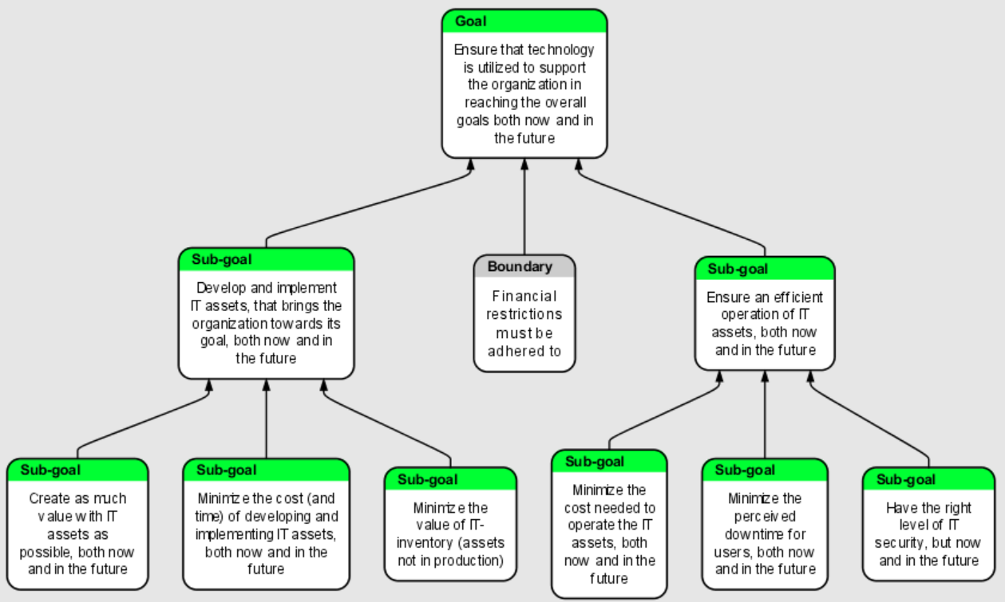
This illustration is, buy now means, directly applicable to any IT function. The specifics of any given organization needs to be taken into account. What is certain, however, is that the illustrated model will be a good place to look for conflicts, identifying metrics and not least defining roles and responsibilities in an organization. In my experience, I have always found the statements in the model relevant in all IT functions. They are, however, not sufficient, but I propose that they are necessary for success.

References
Dettmer, H. William, Strategic Navigation, ASQ Quality Press,2003
Dettmer, H. William, The Logical Thinking Process, ASQ Quality Press, 2007
Eck, Marc van, One Page Business Strategy, Trans-Atlantic Publications, 2004
Goldratt ,Eliyahu M., Necessary But Not Sufficient, North River Press, 2005
Goldratt ,Eliyahu M., The Goal, North River Press, 2014
Kaplan, Robert S. & Norton, David P., The Balanced Scorecard, Harvard Business Review Press, 1996

A goal, in this context, is to be taken in the broadest of terms. It could be a vision, a SMART goal or something else. Whatever is the objective function for measuring success in any given organization.
System is used here in the context of systems thinking.
By extension, it is, naturally, also the role of management to ensure that the company only deploy resources (people, capital, etc.) where there is an actual causal link to the overall goal, however indirect that link might be.
In case it is not used, the landscape becomes more complex and dependent on the organizational design principles used. These cases are, therefore, not included here.
If this assumption is not in place, the proposed goals tree is not valid, since it is to narrowly focused on IT as an support function in the value chain.
Please note that this view is very simplistic. There are a lot of different necessary conditions that needs to be in place for new technology (in the broadest term possible) to bring value to an organization. This dive into this sub-goal is, however, beyond the scope of this article.
In many ways, IT does not equals production, but the analogy works when talking about inventory.

