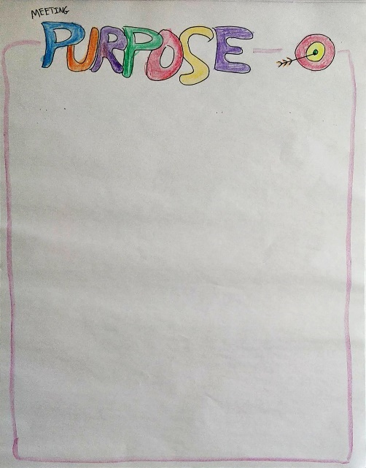 | Purpose  Any meeting should start with a short presentation of the purpose of the meeting. For shorter meetings, a visual representation is not needed. For longer meetings, it’s recommended to keep the purpose visible during the entire meeting to keep the participants on track.  If a meeting is a collection of smaller meetings bundled into one, then skip the purpose for the meeting but ask that each owner for an agenda item quickly starts by stating the purpose of the agenda item.  Start with getting agreement from the participant that the purpose is the right one.  It’s recommended to write directly on the flipchart. If that is not feasible, use post-its.
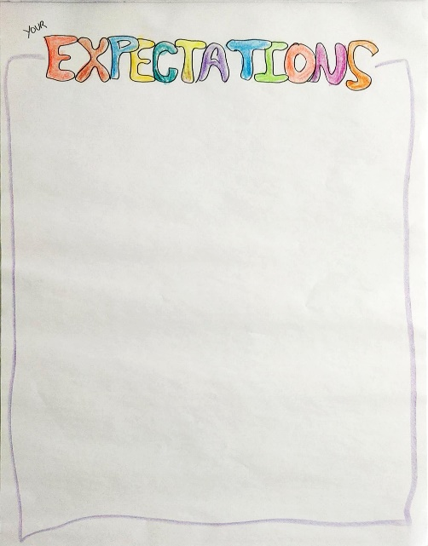 | Expectations (from participants)  In longer sessions with a diverse set of participants, it is recommended to ask the participants what they have of expectations to the meeting.  Depending on the group size, there could be some preparation work in smaller groups before a discussion with the entire room.  Gather all the input and write it as said by the participants. If something seems covered already, ask before you dismiss it.  In the end, comment on the expectations. What can be matched, and what cant. Discuss any changes to the agenda, if needed.
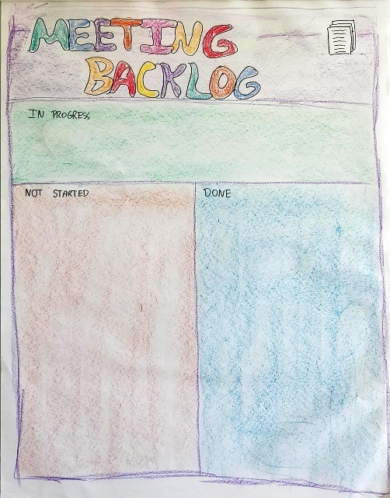 | Meeting backlog (agenda)  Based on both the purpose and the expectations of the participants, it is not time to set the agenda.  Use premade post-its for each agenda item. Put them in the not started column as you talk to each point. If there are several themes or types of agenda items, consider using different colors for the post-its to symbolize this.  Ask if anything is missing and add accordingly.  During the meeting, move the post-it for the current topic to “in progress” and afterward to DONE. This is a nice visual reminder of what we are focusing on now.  If pressed for time, be sure to prioritize the not started column and push any items not processed to another session or other ways of processing.
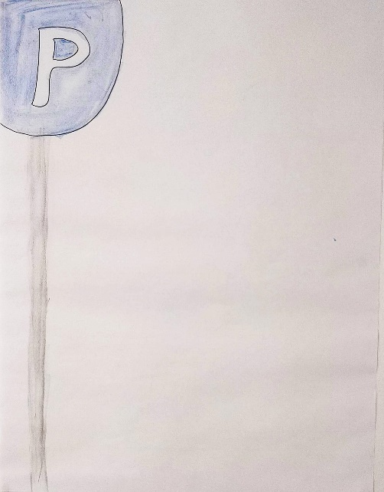 | Parking lot  Discussions often run off on a tangent to the topic at hand. Usually, there is not enough time to process all of these other ideas. Therefore, make a parking lot to help secure focus.  Introduce the parking lot after the agenda as the collective memory for us, to remember topics that surface, but are not part of the agenda. Having the visual reminder is excellent to make sure that the participants feel heard and that the focus of the group can be kept.  Every time a new topic surfaces in the discussions, and you need to close the debate, make a post-it on the point and put it on the parking lot flipchart.  Remember to end the meeting with emptying the parking lot. Emptying is done by processing the items, if there is time, delegating if possible or scheduling a follow-up.
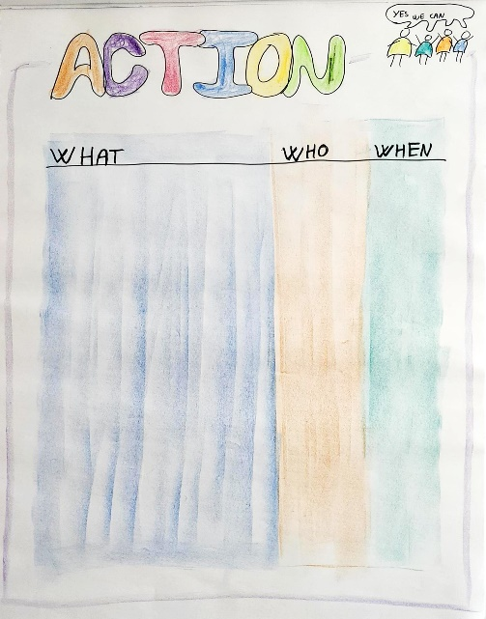 | Actions  During most discussions, someone will need to take action. Decisions should be implemented; something must be investigated, or any other action can pop up during a meeting.  To make sure actions are captured, write them in the simple format of what is done by who by when. Make it visible to all during the meeting.  At the end of the meeting, the action list is reviewed to make sure everyone agrees. Remember to distribute the action list to participants afterward. It could be as simple as taking a picture, or it can be put into a system, depending on the preference of the participants and their modus operandi. When closing the meeting, be sure to gauge their commitment level to implementing the actions. If the commitment is not there, then discuss if something needs to be changed.
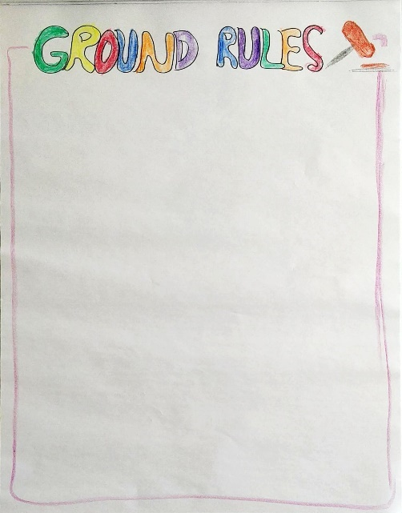 | Ground rules  Depending on the participants, it can be a good idea to define some ground rules for the meeting (or series of meetings). Ground rules describe how you participate and what you expect of each other and yourselves.  Good questions to ask: Think about great meetings, what made them great? How should we act in these meetings to make them efficient?  A different approach is to ask each individual to come up with personal commitments that they will contribute to making the meeting great, and then ask to share. If this is done, then review at the end of the session.  Capture what is said, and if needed get everyone to sign the flipchart for extra buy-in.  Examples of rules can be electronics on stun, let everyone speak, include breaks for every hour, must end on time, etc..
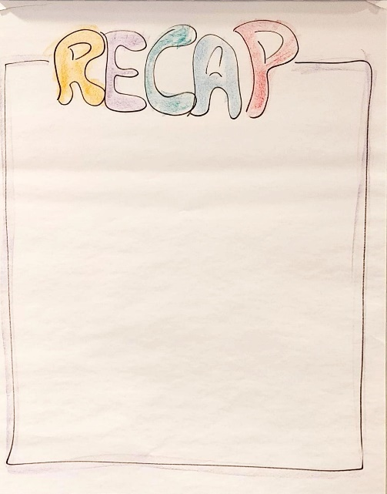 | Recap (from last/previous/etc.)  If a meeting spans a longer period of time, then it is sometimes a good idea to recap what has been covered so far. Using this technique is especially important in workshop and training sessions.  Consider using a recap after lunch, if needed. Always use a recap on day two of a session, if there is no other visual capture of the day before (i.e. if the action log covers it all).  Ask for input and note it down. In larger groups, ask for each group to come up with input, to make the process faster.
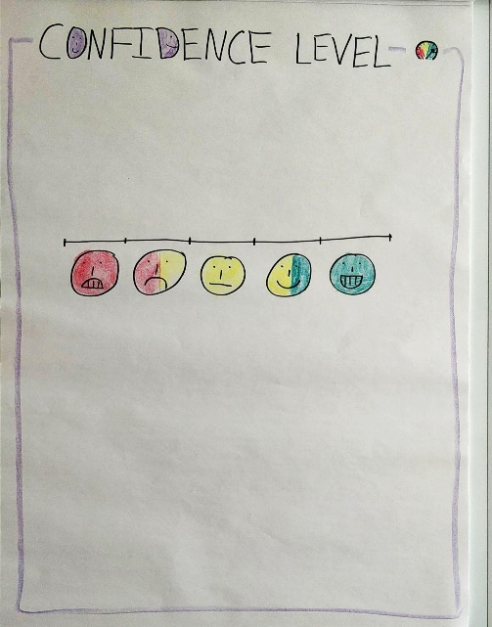 | Confidence level vs. Purpose/expectations  Ending a meeting can be difficult. Did we achieve what we set out to do? A simple and easy way to do this is to ask everyone to dot-vote (put a sticker dot on a scale) on any given topic. In this instance, it is with the question: Did we achieve our purpose, or “are we confident we will succeed with our goal”.  Discuss the results, ask for input from the different scores. Take any needed actions to correct or improve.  Only use this, if it is possible to do something either in the meeting or afterward.
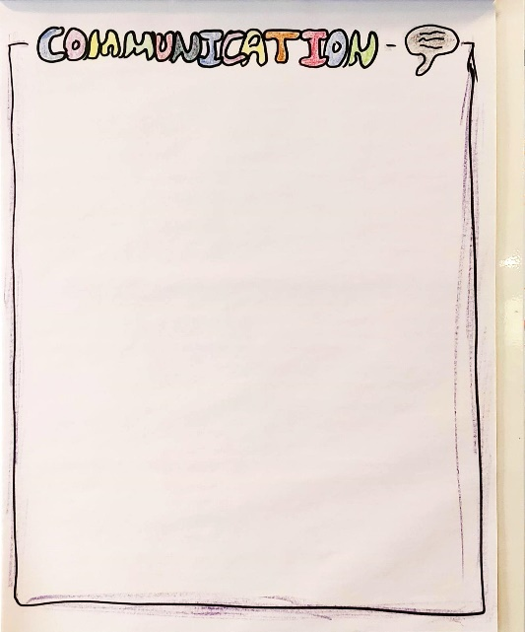 | Communication  Ending a meeting should include a summary of what was achieved. To ensure that each participant shares the same message when they leave the meeting, it is strongly recommended to end each meeting with a simple summary of what to communicate.  Ask the participants for what should be shared from the meeting. Write each point on the flipchart.  Remember to state the actions should also be communicated.
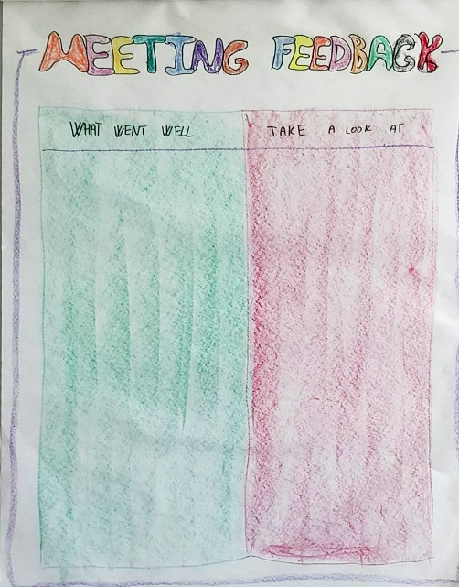 | Meeting feedback / Evaluation  It is good practice to end a meeting by asking what went well, and what should be improved. There are a lot of different methods for doing this.  This method is done by asking each participant to fill out post-its for “what went well” and “take a look at”. Each post-it should be written as a full sentence so that it can be understood later on.  Either share directly and talk about the input as each participant post it (in this case, pre-work in groups can be used) or simply ask everyone to place their post-its on the flipchart placed near the door as their “ticket” to leave the meeting.  No commitments are given based on the evaluation, that is for the facilitator to decide at a later date.
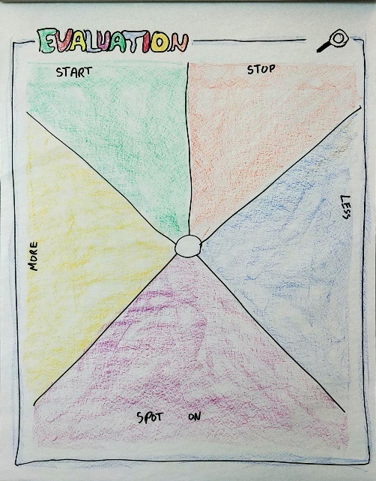 | Meeting feedback / Evaluation  A more elaborate way of working with an evaluation of a meeting is to ask for feedback in more categories. Each category functions as kind of a lens for the mind to come up with ideas for. Ask for input on the following categories: Start, Stop, More, Less, Spot-on (just right).  Ask for input as full sentences, to make it easy to remember when the meeting is post-processed.  This technique also works for task analysis, etc.. Works best in smaller groups due to the detailed level of feedback in the different categories.
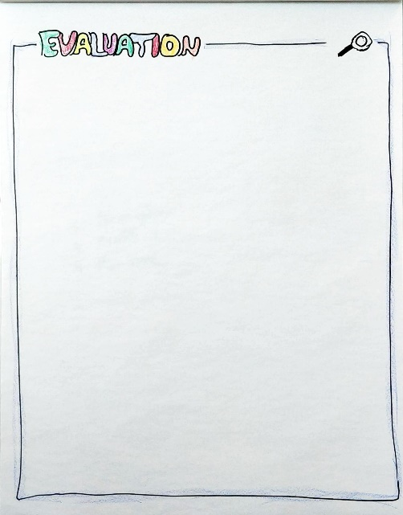 | Meeting feedback / Evaluation  The last type of feedback from a meeting is to ask the question and report the answers given. Remember not to repeat content already recorded but mark it (by underlining or something) that a topic is repeated.  In larger groups, ask smaller groups for input and then collect the aggregate.

